Huong Phan

BIOL/CS 383 Bioinformatics - Module 4 Capstone

**Abstract**

Female mosquitoes detect carbon dioxide through the olfactory cpA neurons in their maxillary palps, which express a family of *Gustatory receptor* genes (*Gr1, Gr2, Gr3*) (Tauxe et al., 2013). Therefore, the hypothesis is that if one or more of these gustatory receptor genes could be found in the antennae, they would be significantly differentially expressed towards human. We analyzed the data of 32 antennae samples of different strains: forest, domestic, mixed and F2 hybrids of female *Aedes aegypti* from the RNAseq experiment in a research of mosquito preference for human related to odorant receptor (McBride et al., 2014), and categorized categorized in the antennae as human-preferring, and guinea pig-preferring, or as having no significant preference towards human or guinea pig. We investigated whether one or more gustatory receptor genes are more differentially expressed in hybrid or non-hybrid population, and whether they are human-preferring (logFC > 0) or guinea pig-preferring (logFC < 0). The results showed that there was only *Gr2* found in the antennae samples in both populations. In the non-hybrid population, *Gr2* gene is more differentially expressed towards human (logFC = 0.6443) than in hybrid population (logFC = 0.23). Both of which is higher than the mean logFC for each population, which is 0.0307 for non-hybrid and 0.0300 for hybrid population. Moreover, *Gr2* was significantly human-preferring in non-hybrid population (p = 0.0428), but was not significantly differentially expressed in hybrid population (p = 0.4875). We also compared the log counts per million (logCPM) of *Gr2* in forest and domestic population, and found that logCPM of *Gr2* for domestic population, which is human-preferring, is generally higher than that for forest population, which is guinea pig-preferring, but the difference is not significant (p = 0.0896). In conclusion, the results partly supported the hypothesis that gustatory receptors are differentially expressed towards human.

**Graphs**

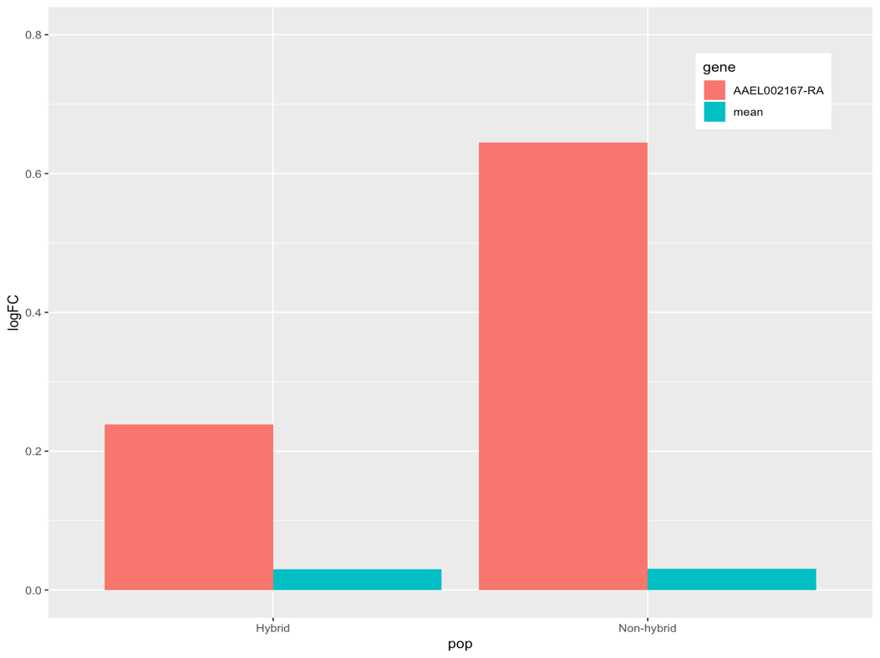

Figure 1. Bar plots of logFC of *Gr2* gene and mean logFC in hybrid and non-hybrid populations

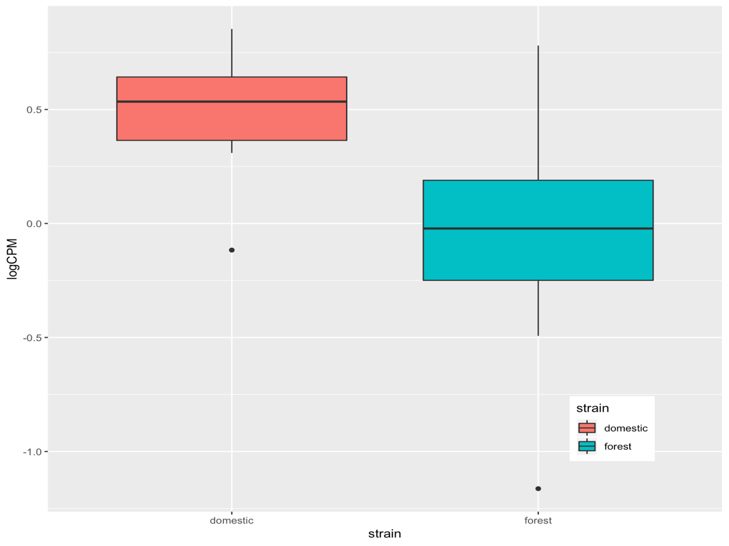

Figure 2. Box plots of logCPM of *Gr2* gene in domestic and forest populations

**References**

Tauxe, Genevieve M., et al. "Targeting a dual detector of skin and CO2 to modify mosquito host seeking." *Cell* 155.6, 2013, pp. 1365-1379.

McBride, Carolyn S., et al. "Evolution of mosquito preference for humans linked to an odorant receptor." *Nature* 515.7526, 2014, pp. 222.